Force problem set

1. When you are holding a bottle, if you double the force you hold it, what might happen to the friction force between your hand and the bottle?
2. In fig, The weight of object A and B are both 10 N. The friction constant between every two surface is 0.3 . Two force F are acting on them(Both of 1 N), what is the friction between the floor and B?

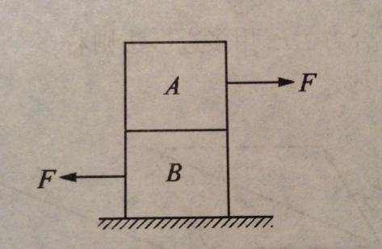

1. In fig, Oa, Ob, Oc are three identical rope. When G becomes bigger, which rope will break first?

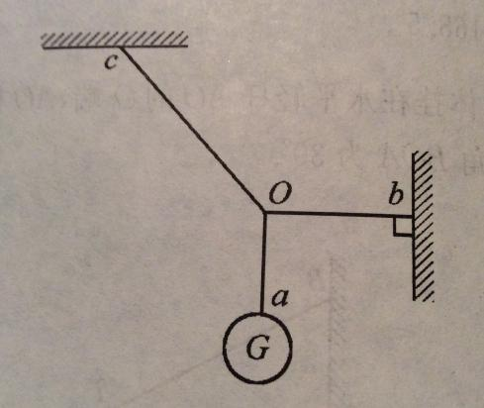

1. A 10 kg block, is hang up with two ropes and a spring. The length of the spring when there’s no force is 1.5cm and k = 7840N/m. The longer rope is 4cm. Find out the force on this rope.

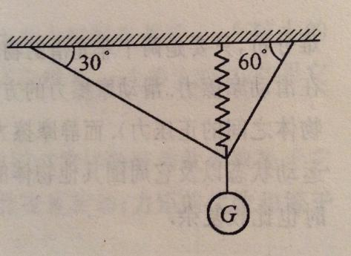

1. A square has a weight of 40N. It is touching the wall and A force of 50 N is pushing at it direct to the wall. The force is also upward and the angle between it and the horizontal is 37°. The friction constant between the square and the wall is 0.4. What is the friction?(sin 37° = 3/5, cos 37° = 4/5)
2. Two rings are on two strings. Now there is a force that is pulling ring Q. When the system become stable, what is the tension?(ignore all the mass and friction, answer in terms of θ and F).

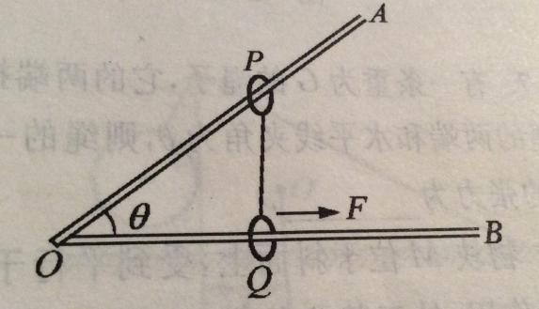

1. As shown in fig a , the block A has a weight of 40N, block B has a weight of 20N, the friction constant between A and ground and A and B are the same. If F >= 32 N, A can be pulled out. When it comes to fig b and both θ is 37°, what is the new minimum F?

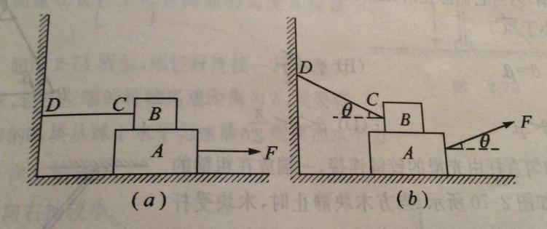

1. In fig, a uniform board has a length of 12m, weight 200 N, can rotate freely about point O. AO = 3m. The rope at B have a maximum tension of 200N. A human weights 600 N is walking along the board, what is the safe distance (between A and the man) for him to walk?

